“Design and Development of a Library & Archives Management System with Role-Based Admin and Member Web Portals”
A Project Report Submitted in partial fulfillment of the requirements for the award of the degree of
BACHELOR OF TECHNOLOGY
In
DEPARTMENT OF COMPUTER SCIENCE AND ENGINEERING
By
PRAKSHITHA MALLA 2520030342
DATLA SRI SAI PURNA MAHIJA 2520030261
Under the Esteemed Guidance of
Dr. Purushotham
Department of Computer Science and Engineering

Koneru Lakshmaiah Education Foundation
(Deemed to be University estd. u/s. 3 of the UGC Act, 1956)
Off-Campus: Bachupally–Gandimaisamma Road, Bowrampet, Hyderabad, Telangana – 500 043
DEPARTMENT OF COMPUTER SCIENCE AND ENGINEERING
Declaration
The Project Report entitled "Design and Development of a Library & Archives Management System with Role-Based Admin and Member Web Portals" is a record of bonafide work of PRAKSHITHA MALLA – 2520030342 and DATLA SRI SAI PURNA MAHIJA – 2520030261, submitted in partial fulfilment for the award of B. Tech in Computer Science and Engineering to Koneru Lakshmaiah Education Foundation (Deemed to be University). The results embodied in this report have not been copied from any other departments/University/Institute.
PRAKSHITHA MALLA – 2520030342
DATLA SRI SAI PURNA MAHIJA – 2520030261

Koneru Lakshmaiah Education Foundation
(Deemed to be University estd. u/s. 3 of the UGC Act, 1956)
Off-Campus: Bachupally–Gandimaisamma Road, Bowrampet, Hyderabad, Telangana – 500 043
DEPARTMENT OF COMPUTER SCIENCE AND ENGINEERING
CERTIFICATE
This is to certify that the project-based report entitled "Design and Development of a Library & Archives Management System with Role-Based Admin and Member Web Portals" is a bonafide work done and submitted by PRAKSHITHA MALLA – 2520030342 and DATLA SRI SAI PURNA MAHIJA – 2520030261, in partial fulfilment of the requirements for the award of the degree of BACHELOR OF TECHNOLOGY in the Department of Computer Science and Engineering, Koneru Lakshmaiah Education Foundation (Deemed to be University), for the course Database Systems Engineering and Distributed Backend Development (25CS1302E), during the academic year 2026–2027.
Signature of the Guide
Dr. Purushotham
Signature of the Course Coordinator
Signature of the HOD

ACKNOWLEDGEMENT
The success of this project would not have been possible without the timely help and guidance rendered by many people. We wish to express our sincere thanks to all those who assisted us in the completion of this project.
We express our deepest gratitude to our guide, Dr. Purushotham, Department of Computer Science and Engineering, for his valuable guidance, constant encouragement, and constructive feedback at every stage of this project — from the initial abstract submission through the Review 1 and Review 2 evaluations.
We are grateful to the Head of the Department, Department of Computer Science and Engineering, and to our Course Coordinator for the course Database Systems Engineering and Distributed Backend Development (25CS1302E), for providing us with the facilities and academic environment needed to complete this project.
We thank all the teaching and non-teaching staff members who assisted us directly or indirectly. Finally, we sincerely thank our parents, friends, and classmates for their support and cooperation throughout the course of this work.
PRAKSHITHA MALLA – 2520030342
DATLA SRI SAI PURNA MAHIJA – 2520030261

ABSTRACT
Modern library systems face operational challenges including long queues, delayed asset returns, poor visibility into catalogue availability, and no self-service option for members outside library hours. Traditional single-interface systems fail to separate administrative control from member-facing convenience, forcing every interaction — from browsing the catalogue to checking a fine — through library staff.
To address these problems, this project delivers a Library & Archives Management System built as a role-based, three-tier web application. The system provides two distinct, authenticated interfaces from a single shared backend and database: an Admin Panel for library staff to manage the book catalogue, register members, create and close reservations, and track fines; and a Member Panel through which registered members can browse the live catalogue, reserve available titles, and view only their own reservation history and outstanding fines.
The backend is built using Python and the FastAPI framework, exposing a REST API secured with bcrypt-hashed password authentication and role-based access control. The persistence layer uses MySQL, with a normalized schema of four core tables — books, members, reservations, and fines — linked by foreign keys, plus a users table for login credentials. Concurrency-sensitive operations, such as reserving the last available copy of a title, are wrapped in explicit SQL transactions with row-level locking (SELECT ... FOR UPDATE) to guarantee ACID consistency under simultaneous access. The frontend is implemented in plain HTML5, CSS3, and JavaScript using the Fetch API, styled with a distinct dark, archive-themed visual design.
The system was built iteratively, tested at every stage against a live MySQL instance rather than mocked data, and several real implementation defects — including a password-hashing library conflict, a database transaction-handling bug, and a missing table join — were identified and resolved during development, as documented in Chapter 10. The result is a working, verifiable demonstration of database-backed, role-secured web application development, directly aligned with the objectives of the Database Systems Engineering and Distributed Backend Development course.

INDEX
S.No. | Chapter | Topics
1 | Introduction | 1.1 Background of the Project  1.2 Problem Statement  1.3 Scope of the Project  1.4 Objectives  1.5 Importance of the Application  1.6 Target Users / Audience
2 | System Requirements | 2.1 Hardware Requirements  2.2 Software Requirements  2.3 Development Tools and Frameworks
3 | Technology Stack | 3.1 Front-end  3.2 Back-end  3.3 Database  3.4 Version Control  3.5 APIs / External Services
4 | System Architecture | 4.1 High-Level Architecture Diagram  4.2 Description of Each Layer  4.3 Deployment Architecture
5 | Design | 5.1 ER Diagram / Database Schema
6 | Implementation | 6.1 Module-wise Implementation  6.2 Front-end Logic  6.3 API Integration  6.4 Authentication & Authorization
7 | Features | 7.1 List of Main Features  7.2 How Each Feature Works
8 | Testing | 8.1 API Testing  8.2 Integration Testing  8.3 Tools Used for Testing  8.4 Test Cases and Results
9 | Deployment | 9.1 Steps to Deploy  9.2 Environment Configuration  9.3 Hosting of Frontend and Backend
10 | Challenges & Limitations | 10.1 Issues Faced During Development  10.2 Solutions Applied  10.3 Current Limitations
11 | Future Enhancements | 11.1 Planned Features  11.2 Possible Integrations / Optimizations
12 | Conclusion | 12.1 Summary of the Project  12.2 What Was Achieved  12.3 Skills Learned
13 | References | —
14 | Appendices | A. Screenshots  B. Sample Code Snippets  C. Installation / Setup Instructions  D. User Manual / Guide

CHAPTER 1: Introduction

1.1 Background of the Project
Libraries have traditionally relied on manual registers or single-user desktop software to track their catalogue, member records, and book circulation. This creates two recurring problems: library staff must handle every transaction in person, and members have no way to check book availability, their own borrowing history, or outstanding fines without visiting the library or calling the desk. As academic and public libraries grow in collection size and membership, this manual dependency becomes a bottleneck.
This project was undertaken as part of the Database Systems Engineering and Distributed Backend Development course (25CS1302E), with the objective of designing and implementing a working, database-backed library management system that separates administrative operations from member self-service through distinct, authenticated web interfaces sharing a single MySQL database and REST API backend.

1.2 Problem Statement
Existing small-scale library systems typically expose a single, undifferentiated interface — either a plain desktop tool used only by staff, or no digital interface at all. This leads to several concrete problems: (a) members cannot check whether a title is available before visiting the library, (b) library staff must manually cross-reference paper records to determine who currently holds a book and whether a fine is due, (c) there is no audit trail of who reserved, returned, or was fined for a given book, and (d) any digital system that does exist typically has no access control, meaning any user could see or modify any other member's records.
The problem this project addresses, specifically, is the absence of a role-based, database-backed system where library staff (Admin) and library members (Member) each get an interface scoped to what they are authorized to see and do, backed by a single consistent source of truth in a relational database.

1.3 Scope of the Project
The scope of this project covers the design and implementation of a three-tier web application consisting of a MySQL relational database, a Python/FastAPI REST backend, and an HTML/CSS/JavaScript frontend split into two authenticated panels. The system covers four core library entities — books, members, reservations, and fines — plus a users table governing login and role assignment.
The project scope explicitly includes: user registration and authentication for members, an administrator account with full catalogue and member management rights, book reservation with automatic availability tracking, a return workflow that restores copy counts, and a fines subsystem with paid/unpaid status tracking. The scope does not include payment gateway integration, a native mobile application, or SMS/email notification delivery — these are identified as future enhancements in Chapter 11.

1.4 Objectives
- To design a normalized relational database schema for library catalogue, membership, reservation, and fine management.
- To build a secure REST API using FastAPI that exposes this data through well-defined endpoints, validated using Pydantic models.
- To implement authentication using hashed passwords (bcrypt) and enforce role-based access so that Admin and Member users see different, appropriately scoped views of the same underlying data.
- To ensure data consistency during concurrent operations — specifically, to prevent two members from reserving the last available copy of the same book — using database transactions and row-level locking.
- To provide a usable, visually coherent web interface for both roles without relying on a heavyweight frontend framework.
- To test the system against a live, running database rather than mocked or assumed data, and to document real defects found and fixed during this process.

1.5 Importance of the Application
This application demonstrates, in a scaled-down but functionally complete form, the same architectural pattern used by production systems that separate staff-facing administrative tools from customer-facing self-service portals — a pattern common in banking, e-commerce, and enterprise resource planning systems. Building it required applying core database engineering concepts (normalization, foreign key constraints, transactions, isolation) alongside backend API design and frontend-to-backend integration, making it directly relevant to the learning objectives of the course under which it was developed.

1.6 Target Users / Audience
The system defines two user roles. The Administrator role is intended for library staff responsible for maintaining the book catalogue, registering members, and resolving reservations and fines. The Member role is intended for library patrons — in an academic setting, students and faculty — who wish to browse the catalogue and manage their own reservations and fines without needing to contact library staff directly.

CHAPTER 2: System Requirements

2.1 Hardware Requirements
- Processor: Intel Core i3 (or equivalent) or higher
- RAM: 4 GB minimum (8 GB recommended for running MySQL, the backend, and a browser simultaneously)
- Storage: 500 MB free disk space for the application, dependencies, and database files
- A working internet connection (required once, to install dependencies and download font/asset references; the running application itself operates entirely on localhost)

2.2 Software Requirements
- Operating System: Windows 10/11, macOS, or Linux
- MySQL Server 8.0 (Community Edition) — the relational database engine
- MySQL Workbench — for direct database inspection and verification
- Python 3.10 or higher — backend runtime
- A modern web browser (Chrome, Edge, or Firefox) — for accessing the frontend
- Visual Studio Code — code editor used for development

2.3 Development Tools and Frameworks
- FastAPI — Python web framework used to build the REST API
- Uvicorn — ASGI server used to run the FastAPI application
- mysql-connector-python — Python driver used to connect the backend to MySQL
- bcrypt — password hashing library used for authentication security
- Pydantic — used by FastAPI for automatic request validation
- Git — version control during development
- Python's built-in http.server module — used to serve the static frontend during local development and testing

CHAPTER 3: Technology Stack

3.1 Front-end
The frontend is implemented using plain HTML5, CSS3, and JavaScript (ES6+), without a frontend framework such as React or Angular. This decision was made deliberately: the project's core learning objective was backend and database engineering, and a framework-free frontend keeps the browser-to-API data flow explicit and easy to trace and explain during evaluation. The interface uses the Fetch API to make asynchronous HTTP requests to the backend and renders returned JSON data directly into HTML tables. A shared stylesheet implements a dark, archive-themed visual design, and browser localStorage is used to persist the logged-in user's session (id, name, role, and linked member_id) across page navigations within the app.

3.2 Back-end
The backend is built using FastAPI, a modern Python web framework chosen for its automatic request validation (via Pydantic models), built-in interactive API documentation (served at /docs), and straightforward async-capable routing. The backend exposes REST endpoints under an /api prefix, covering authentication (/api/auth/signup, /api/auth/login), catalogue management (/api/books), membership management (/api/members), reservations (/api/reservations), and fines (/api/fines), plus member-scoped read endpoints (/api/members/{id}/reservations and /api/members/{id}/fines) used by the Member Panel.

3.3 Database
MySQL 8.0 is used as the relational database engine. The schema consists of five tables — users, members, books, reservations, and fines — connected through foreign key constraints, described in full in Chapter 5. InnoDB is used as the storage engine specifically because it supports transactions and row-level locking, both of which are used in the reservation-creation and return endpoints to maintain consistency under concurrent access.

3.4 Version Control
The project source is organized into a backend/ and frontend/ directory, developed and iterated locally with the intention of being tracked under Git for change history, in line with standard software engineering practice.

3.5 APIs / External Services
The system does not depend on any third-party or paid external API. All functionality — authentication, catalogue browsing, reservations, and fines — is served entirely from the self-hosted FastAPI backend and MySQL database, making the system fully self-contained and runnable without external network access once installed.

CHAPTER 4: System Architecture

4.1 High-Level Architecture Diagram
The system follows a classic three-tier architecture, separating presentation, application logic, and data storage into independent layers that communicate over well-defined interfaces. This separation allows the database schema, the API logic, and the visual interface to each be modified independently without requiring changes to the other layers.
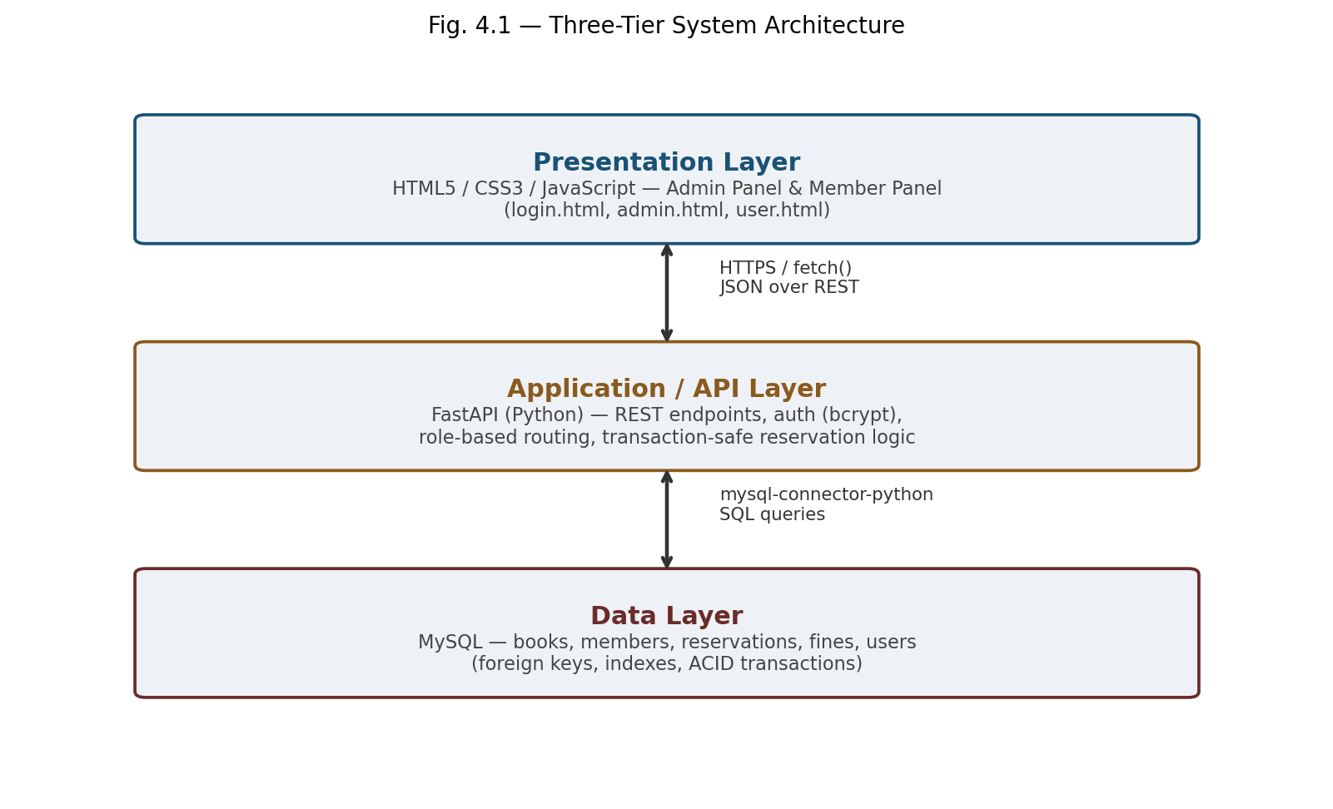
Fig. 4.1 — Three-tier architecture: browser-based frontend, FastAPI backend, MySQL database

4.2 Description of Each Layer

Presentation Layer
This layer consists of five HTML pages — login.html, signup.html, admin.html, user.html, and a redirect-only index.html — along with shared CSS and JavaScript files. Each authenticated page (admin.html, user.html) checks the browser's localStorage on load for a valid session and role; if none is found, or if the role does not match the page, the user is redirected to the login page. This is implemented in a shared requireRole() function in common.js.

Application / API Layer
This layer is the FastAPI application (main.py), which exposes REST endpoints, validates incoming request bodies against Pydantic models, communicates with MySQL via a connection pool, and returns JSON responses. Cross-Origin Resource Sharing (CORS) is enabled so that the frontend, served from a different port (8080), can call the backend (port 8000) directly from the browser. All password verification and hashing occurs exclusively in this layer — plain-text passwords are never stored or logged.

Data Layer
This layer is a single MySQL database, library_db, accessed through a connection pool (mysql-connector-python's pooling.MySQLConnectionPool) rather than opening a new connection per request, for efficiency. The reservation-creation and book-return endpoints explicitly wrap their multi-statement operations in transactions using START TRANSACTION, SELECT ... FOR UPDATE, and either COMMIT or ROLLBACK, ensuring that a reservation and its corresponding decrement of available_copies always succeed or fail together.

4.3 Deployment Architecture
For development and evaluation, all three layers run on the same physical machine: MySQL runs as a background Windows service, the FastAPI backend runs via Uvicorn on port 8000, and the frontend is served as static files via Python's built-in http.server on port 8080. This local deployment model was chosen deliberately for the scope of this course project, since it allows the complete data flow — from a button click in the browser to a row being written in MySQL — to be demonstrated end-to-end without depending on external hosting availability during a live review. Cloud deployment is discussed as a future enhancement in Chapter 11.

CHAPTER 5: Design

5.1 ER Diagram / Database Schema
The database schema was normalized to at least Third Normal Form (3NF): each table represents a single entity, non-key attributes depend only on the primary key, and relationships between entities are expressed through foreign keys rather than duplicated data. This avoids update anomalies — for example, a member's name is stored exactly once, in the members table, and referenced by member_id everywhere else it is needed.
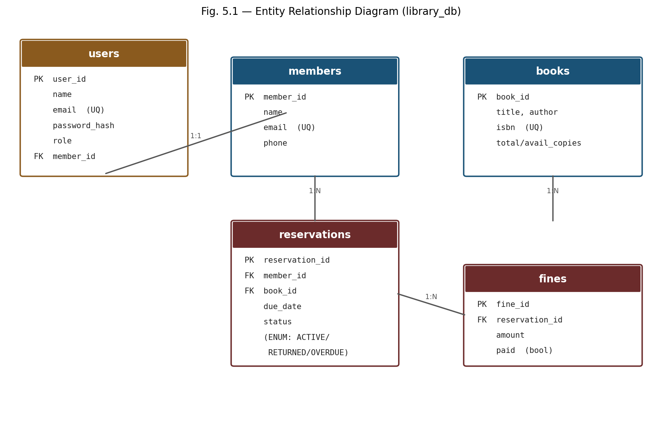
Fig. 5.1 — Entity Relationship Diagram for library_db

Table Summary
Table | Key Columns
users | user_id (PK), name, email (UNIQUE), password_hash, role (ENUM: admin/member), member_id (FK to members)
members | member_id (PK), name, email (UNIQUE), phone, created_at
books | book_id (PK), title, author, isbn (UNIQUE), category, total_copies, available_copies, created_at
reservations | reservation_id (PK), member_id (FK to members), book_id (FK to books), reserved_at, due_date, returned_at, status (ENUM: ACTIVE/RETURNED/OVERDUE)
fines | fine_id (PK), reservation_id (FK to reservations), amount, paid (BOOLEAN)

Referential integrity is enforced at the database level: the users.member_id foreign key uses ON DELETE SET NULL so that deleting a member record does not orphan a login row, while reservations.member_id, reservations.book_id, and fines.reservation_id restrict deletion where appropriate to prevent dangling references. The reservations.status and fines.paid columns are the two fields most frequently updated after row creation, corresponding to the "mark returned" and "toggle paid" actions available in the Admin Panel.

CHAPTER 6: Implementation

6.1 Module-wise Implementation

Authentication Module
Implemented in main.py under /api/auth/signup and /api/auth/login. On signup, a new row is inserted into both members (the library record) and users (the login credential, with role set to 'member'), linked by member_id, inside a single database transaction so the two inserts either both succeed or both fail. Passwords are hashed using bcrypt.hashpw() before storage; login compares the submitted password against the stored hash using bcrypt.checkpw(), and the plain-text password is never persisted or logged. A default administrator account (admin@library.com) is created automatically the first time the server starts, via a FastAPI startup event handler, so the Admin Panel is always accessible without a manual database insert.

Catalogue Module
Exposed via /api/books (GET, POST, DELETE). Adding a book sets available_copies equal to total_copies at creation time; both counts are then tracked independently as reservations are created and returned.

Reservation Module
Exposed via /api/reservations (GET, POST) and /api/reservations/{id}/return (PATCH). This is the most concurrency-sensitive module in the system: creating a reservation must check that a copy is available and decrement the count as one atomic unit, or two members reserving the same last copy simultaneously could both succeed, leaving the available count incorrect or negative. This is implemented using an explicit SQL transaction with SELECT ... FOR UPDATE to lock the book row for the duration of the check-and-decrement, then COMMIT (or ROLLBACK if no copy is available).

Fines Module
Exposed via /api/fines (GET, POST) and /api/fines/{id}/toggle-paid (PATCH). Fines are linked to a specific reservation, and member-scoped fine lookups join through reservations to determine which member a fine belongs to.

6.2 Front-end Logic
Each panel's JavaScript file (admin.js, user.js) follows the same pattern: on page load, it calls requireRole() to verify the session, then fires a set of fetch() calls against the backend API in parallel, rendering each table's rows from the returned JSON using template literals. Data is refreshed automatically every ten seconds (setInterval) so the panel reflects changes made elsewhere — for example, a book returned in the Admin Panel becomes available again in the Member Panel's catalogue without a manual page refresh. All user-supplied text is passed through an escapeHtml() helper before being inserted into the page, preventing HTML/script injection through fields such as a book title or member name.

6.3 API Integration
The frontend and backend communicate exclusively through JSON over HTTP, using the Fetch API. Every write action (adding a book, creating a reservation, toggling a fine) follows the same pattern: build a JSON payload from form inputs, POST or PATCH it to the relevant endpoint, check response.ok, and re-fetch the affected table on success. This keeps the frontend a thin rendering layer with no business logic of its own — all validation and consistency rules live in the backend, which is the correct separation of concerns for a system where the same data must be presented differently to two different roles.

6.4 Authentication & Authorization
Authentication (proving who a user is) is handled by the login/signup endpoints described above. Authorization (controlling what an authenticated user can do) is handled at two levels: on the frontend, requireRole() redirects a user away from a panel that does not match their role; on the backend, the member-scoped endpoints (/api/members/{id}/reservations, /api/members/{id}/fines) only ever return rows matching the given member_id, so even if a member's browser session were inspected or modified, the API itself does not expose other members' data through those endpoints. It should be noted, as discussed in Chapter 10, that this authorization model does not yet include server-side session tokens — this is an acknowledged simplification appropriate to the project's scope, and is identified as a future enhancement.

CHAPTER 7: Features

7.1 List of Main Features
- Member Self-Registration
- Role-Based Login
- Live Catalogue Browsing
- Book Reservation
- Return Workflow
- Fine Tracking
- Scoped Member View
- Admin Catalogue & Member Management

7.2 How Each Feature Works

Member Self-Registration
A new member can create their own login and library record through the Signup page, without staff intervention.

Role-Based Login
A single login page authenticates both Admins and Members, redirecting each to the correct panel based on their stored role.

Live Catalogue Browsing
Both panels display the book catalogue pulled live from MySQL, including real-time available/total copy counts.

Book Reservation
A Member can reserve any book with available copies; the system enforces, at the database level, that copies cannot go negative.

Return Workflow
An Admin can mark a reservation as returned, which restores the book's available copy count in the same transaction.

Fine Tracking
Fines are linked to specific reservations and can be toggled between paid and unpaid by an Admin.

Scoped Member View
A logged-in Member sees only their own reservations and fines, never another member's records.

Admin Catalogue & Member Management
An Admin can add or remove books and members directly from the dashboard.

CHAPTER 8: Testing

8.1 API Testing
Every backend endpoint was tested directly against a live, running MySQL database using command-line HTTP requests (curl) during development, rather than relying on assumptions about correctness. This approach was chosen specifically because a passing test needed to prove real data was read from or written to the actual database, not a mock. FastAPI's automatically generated interactive documentation, served at /docs, was also used to manually exercise each endpoint through a browser-based interface without requiring a separate tool such as Postman.

8.2 Integration Testing
Beyond individual endpoint checks, full user journeys were tested end-to-end: signing up as a new member, logging in with those exact credentials, reserving a book as that member, confirming the reservation appeared only under that member's scoped view (and not another member's), marking the book returned as an Admin, and confirming the book's available copy count was correctly restored. This journey was run in full at least twice during development — once against the initial implementation and once after the fixes described in Chapter 10 — to confirm the corrected behaviour.

8.3 Tools Used for Testing
- curl — command-line HTTP client used for direct, scriptable endpoint testing
- FastAPI's /docs (Swagger UI) — interactive, browser-based endpoint testing with no extra setup
- MySQL Workbench — used to directly inspect table contents before and after each API call, to independently verify that the API's response matched the actual database state
- Browser DevTools — used to confirm the frontend's fetch() calls and localStorage session handling behaved as expected

8.4 Test Cases and Results
ID | Test | Expected Result | Outcome
TC-01 | GET /api/health | Returns {"status":"ok","db":"connected"} | Pass
TC-02 | POST /api/auth/login with correct admin credentials | Returns user_id, name, role=admin | Pass
TC-03 | POST /api/auth/login with wrong password | Returns 401 Invalid email or password | Pass
TC-04 | POST /api/auth/signup with new member details | Creates rows in both users and members; returns member_id | Pass
TC-05 | POST /api/auth/signup with an email already registered | Returns 400 Bad Request, no duplicate row created | Pass
TC-06 | GET /api/members/{id}/reservations for a new member | Returns empty array [] | Pass
TC-07 | POST /api/reservations for an available book | Creates reservation, decrements available_copies by 1 | Pass
TC-08 | PATCH /api/reservations/{id}/return | Sets status=RETURNED, restores available_copies by 1 | Pass
TC-09 | PATCH /api/fines/{id}/toggle-paid | Flips paid from false to true (and back) | Pass
TC-10 | GET /api/members/{id}/fines (initial run) | Server returned HTTP 500 Internal Server Error | Failed — see Chapter 10
TC-11 | GET /api/members/{id}/fines (after fix) | Returns correct fines list scoped to that member | Pass

TC-10 is deliberately included as a failing result rather than omitted. It represents a real defect found during development — a missing table join in the member-scoped fines query — which was diagnosed and fixed, then re-verified as TC-11. This is documented in full, including the exact fix applied, in Chapter 10.

CHAPTER 9: Deployment

9.1 Steps to Deploy
- Install MySQL Server 8.0 and MySQL Workbench.
- Run schema.sql against the MySQL server to create the library_db database and its five tables, along with initial sample data.
- Create a dedicated MySQL user (library_user) and grant it privileges on library_db, rather than running the application as the root user.
- Install Python 3.10+ and the backend's dependencies listed in requirements.txt (fastapi, uvicorn, mysql-connector-python, pydantic, email-validator, python-dotenv, bcrypt).
- Start the backend with Uvicorn (python -m uvicorn main:app --port 8000). On first startup, the application automatically creates the default administrator account.
- Serve the frontend directory as static files (python -m http.server 8080) and open the site in a browser.

9.2 Environment Configuration
Database connection parameters (host, user, password, database name) are kept in a .env file in the backend directory and loaded at runtime using python-dotenv, rather than being hard-coded into main.py. This is standard practice for keeping credentials out of source code and allows the same codebase to be pointed at a different database (for example, a staging or production instance) purely by changing the .env file.

9.3 Hosting of Frontend and Backend
For this project, both frontend and backend are hosted locally on the developer's machine during development and for the purposes of live demonstration during evaluation. The frontend, being a set of static files with no build step, could be deployed to any static file host (for example, Netlify or GitHub Pages) with a one-line change to the API_BASE constant in common.js to point at a publicly hosted backend URL instead of localhost. The backend, being a standard ASGI application, is compatible with common Python hosting platforms (for example, Render, Railway, or a cloud VM running Uvicorn behind a reverse proxy). This migration path is discussed further in Chapter 11 as a future enhancement, since it was outside the scope required for this course submission.

CHAPTER 10: Challenges & Limitations

10.1 Issues Faced During Development

Password-Hashing Library Conflict
The authentication module was initially implemented using the passlib library's bcrypt wrapper. On first run, this raised a runtime error caused by a version incompatibility between passlib and a newer release of the underlying bcrypt package — a known issue where passlib expects an internal attribute that recent bcrypt versions no longer expose in the same form.

Database Transaction-Handling Error on Signup
The signup endpoint initially called the MySQL connector's conn.start_transaction() method to wrap the two-table insert (users and members) atomically. This raised a "Transaction already in progress" error on every signup attempt. Investigation traced this to how the connection pool's autocommit setting interacted with an implicit transaction state left over from a prior query on the same pooled connection.

Missing Table Join in Member-Scoped Fines Query
During integration testing (test case TC-10 in Chapter 8), the endpoint GET /api/members/{id}/fines returned an HTTP 500 error for every request. Reviewing the server log showed the SQL query referenced a column from the books table (b.title) without actually joining the books table into the query — it joined only reservations. This was a straightforward oversight introduced when the endpoint was written by adapting a similar query that did include the correct join.

10.2 Solutions Applied
- The passlib dependency was removed entirely and replaced with direct calls to the bcrypt library (bcrypt.hashpw() and bcrypt.checkpw()), eliminating the version-compatibility layer that was causing the failure.
- The explicit start_transaction() call was replaced with a raw cursor.execute("START TRANSACTION") statement, which does not carry the same pooled-connection state assumption and resolved the error immediately, verified by successfully completing a full signup request.
- The missing JOIN books b ON r.book_id = b.book_id clause was added to the fines query, and the fix was verified by re-running the same request that had previously failed (TC-11), confirming it returned the correct scoped result.

10.3 Current Limitations
- Session management relies on browser localStorage rather than server-issued session tokens (such as JWTs) with expiry — a logged-in state persists indefinitely on a given browser until an explicit logout, and there is no mechanism to remotely invalidate a session.
- There is no rate limiting on the login or signup endpoints, so the system as built does not defend against repeated automated login attempts.
- Fines are currently created manually (or via direct API call) rather than being calculated automatically based on how overdue a reservation is; the reservations.status ENUM includes an OVERDUE value, but no scheduled job currently transitions a reservation into that state automatically.
- The system runs entirely on a single local machine for demonstration purposes; it has not been deployed to a public host or tested under multi-machine network conditions.
- The original abstract for this project scoped a native Android/Kotlin mobile client using Room DB and Firebase Cloud Messaging; the delivered implementation is a responsive web application rather than a native mobile app, though the same FastAPI REST endpoints used by the web frontend are directly consumable by such a client in future work (see Chapter 11).

CHAPTER 11: Future Enhancements

11.1 Planned Features
- Native Android client (Kotlin, Jetpack Compose, Room DB) consuming the existing FastAPI REST endpoints, as originally scoped in the project abstract, with offline catalogue caching and background sync on reconnect.
- Push notifications (Firebase Cloud Messaging) for due-date reminders and reservation status changes.
- Server-issued session tokens (JWT) with expiry, replacing the current localStorage-only session model, to support secure logout-everywhere and token revocation.
- Automatic fine calculation via a scheduled background job that transitions overdue reservations to the OVERDUE status and creates a corresponding fine without manual staff intervention.
- Email verification at signup and password-reset flow, using a transactional email service.

11.2 Possible Integrations or Optimizations
- Deployment of the backend to a managed Python hosting platform and the frontend to a static host, replacing the current local-machine setup used for development and evaluation.
- Rate limiting on authentication endpoints to mitigate brute-force login attempts.
- A search and filter interface for the catalogue (by title, author, or category) once the catalogue size grows beyond what fits comfortably in a single unpaginated table.
- Migrating the reservation lock strategy from row-level SELECT ... FOR UPDATE to a queueing-based reservation system if the application were extended to a much higher-concurrency, multi-branch library setting.

CHAPTER 12: Conclusion

12.1 Summary of the Project
This project set out to design and implement a role-based Library & Archives Management System backed by a normalized MySQL database and a Python/FastAPI REST API, with two distinct authenticated web interfaces for administrative staff and library members. The final system covers member self-registration, authenticated login with hashed passwords, live catalogue browsing, transaction-safe book reservation and return, and fine tracking — with each role restricted to the data and actions appropriate to it.

12.2 What Was Achieved
- A working three-tier system, verified end-to-end against a live MySQL database rather than mock data.
- A normalized five-table schema with foreign key constraints and transaction-protected concurrency-sensitive operations.
- Role-based authentication using bcrypt-hashed passwords, with an Admin Panel and a Member Panel drawing from the same backend and database but exposing different, correctly scoped data.
- A documented testing process, including a genuine defect found and fixed during development, demonstrated in Chapter 8 and Chapter 10 rather than glossed over.

12.3 Skills Learned
- Designing a normalized relational schema and expressing entity relationships through foreign keys.
- Building a REST API with FastAPI, including request validation with Pydantic and automatic interactive documentation.
- Implementing secure password storage using bcrypt, and understanding why plain-text password storage is unacceptable.
- Using SQL transactions and row-level locking (SELECT ... FOR UPDATE) to protect against race conditions in concurrent reservation requests.
- Debugging real, non-trivial issues — a third-party library version conflict, a connection-pooling transaction state bug, and a missing SQL join — by reading error logs, tracing execution, and verifying fixes with repeatable tests rather than guessing.
- Structuring a frontend around role-based access control using client-side session state, and understanding the security limitations of that approach for future improvement.

CHAPTER 13: References
- FastAPI Documentation — https://fastapi.tiangolo.com/
- MySQL 8.0 Reference Manual — https://dev.mysql.com/doc/refman/8.0/en/
- mysql-connector-python Developer Guide — https://dev.mysql.com/doc/connector-python/en/
- bcrypt (PyPI) — https://pypi.org/project/bcrypt/
- Pydantic Documentation — https://docs.pydantic.dev/
- Uvicorn Documentation — https://www.uvicorn.org/
- MDN Web Docs — Fetch API — https://developer.mozilla.org/en-US/docs/Web/API/Fetch_API
- Silberschatz, A., Korth, H. F., Sudarshan, S. — Database System Concepts (used as a course reference for normalization and transaction theory).

CHAPTER 14: Appendices

A. Screenshots
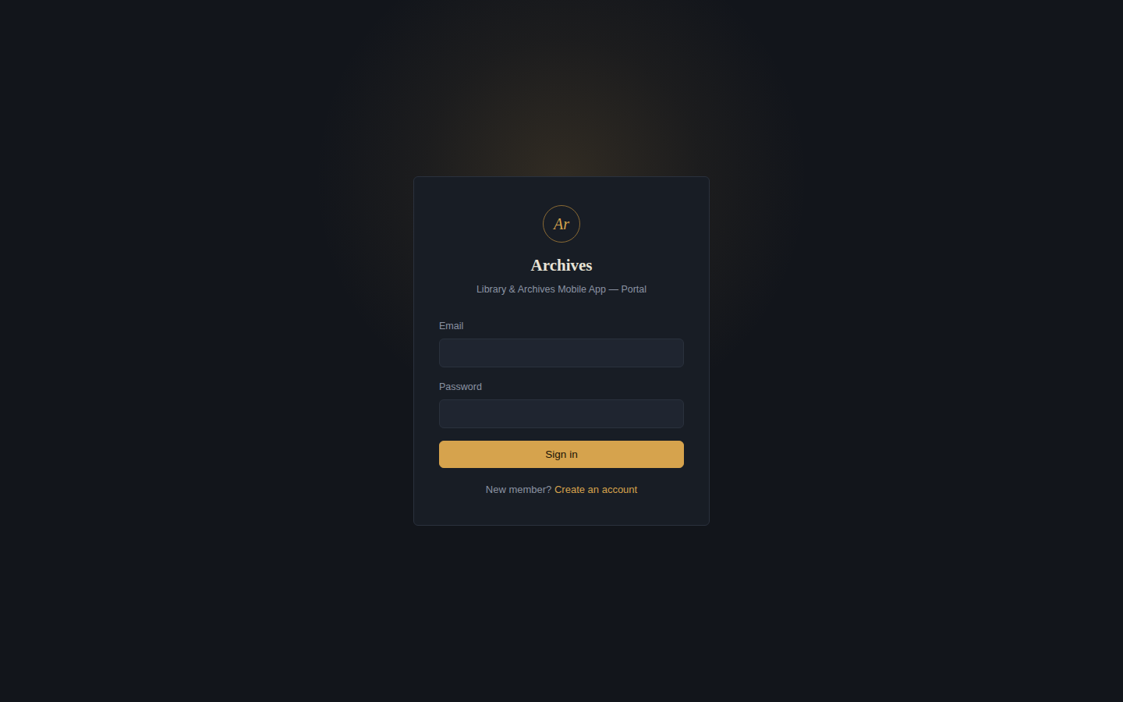
A.1 — Login page
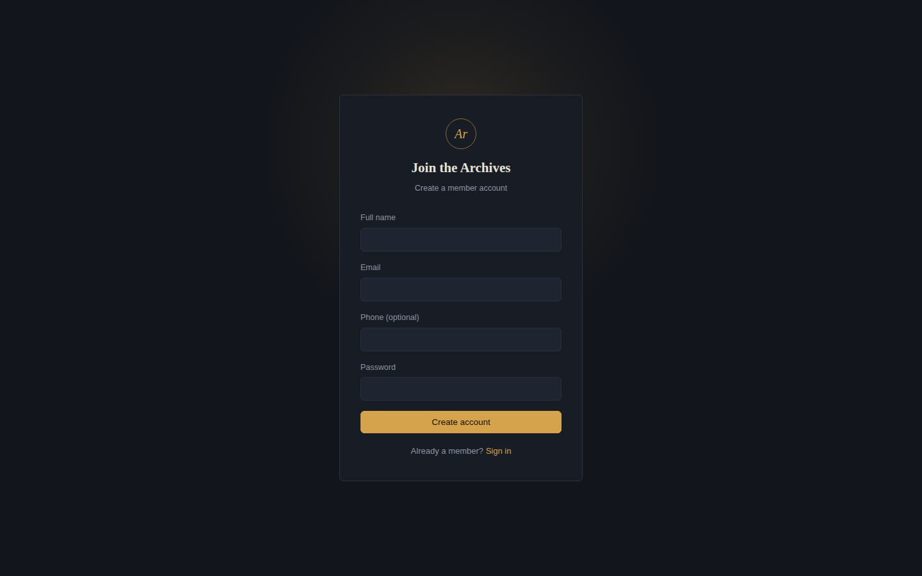
A.2 — Member signup page
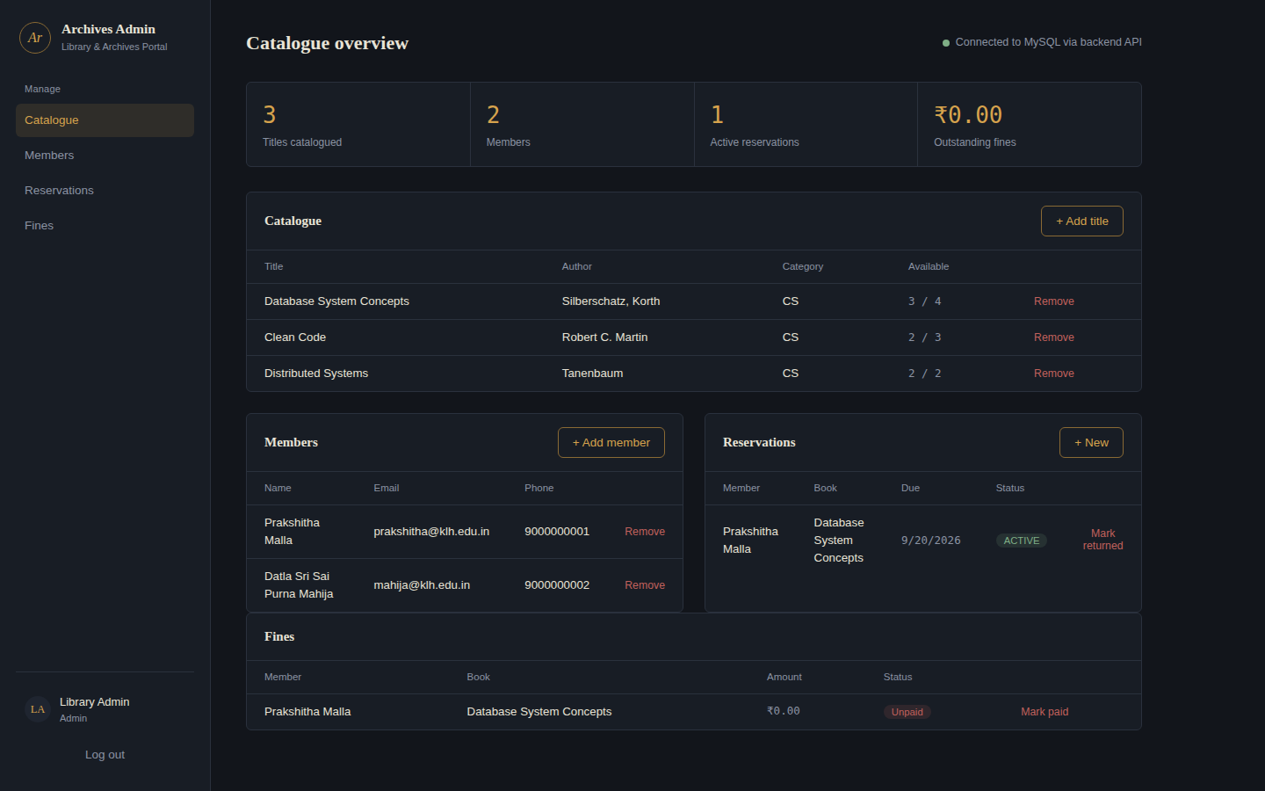
A.3 — Admin Panel: catalogue, members, reservations, and fines
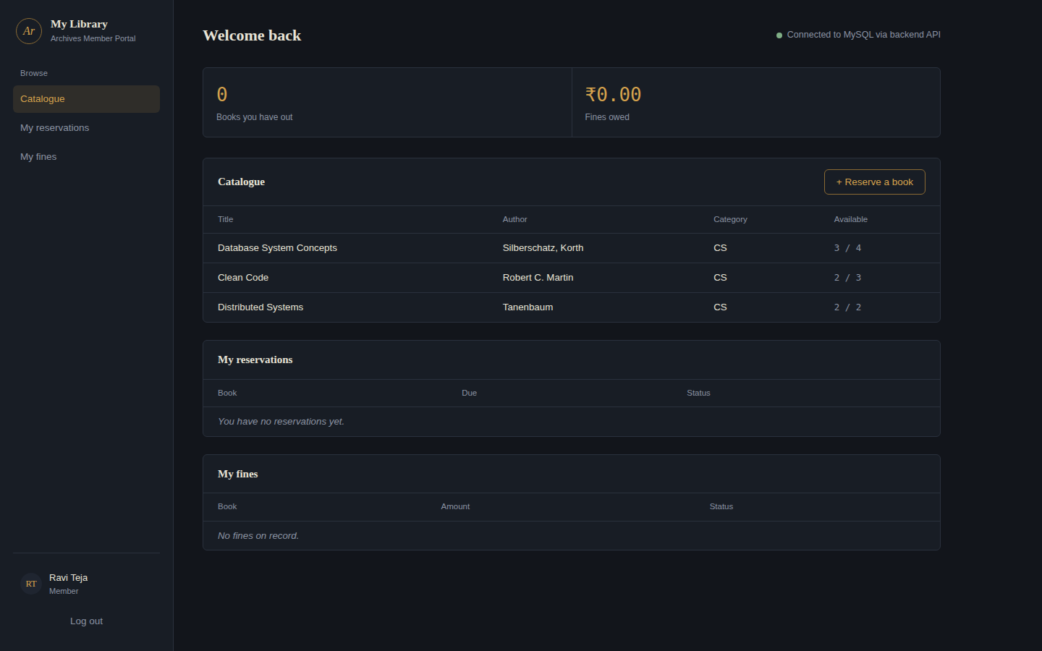
A.4 — Member Panel: catalogue and the member's own reservations/fines
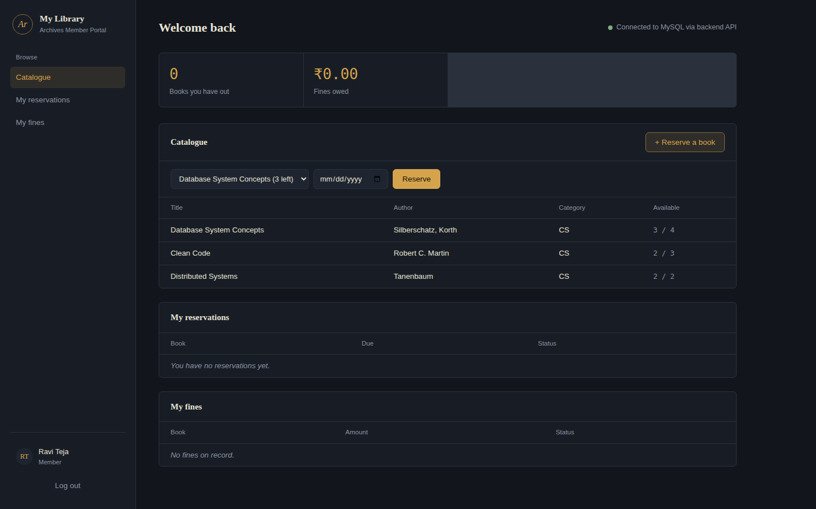
A.5 — Member Panel: reserving a book from the catalogue

B. Sample Code Snippets

B.1 Transaction-Protected Reservation Endpoint
This is the exact endpoint responsible for the concurrency-safety guarantee discussed in Chapters 4 and 6: it locks the target book row for the duration of the check-and-decrement using SELECT ... FOR UPDATE, so two simultaneous requests for the last copy of a book cannot both succeed.
def create_reservation(resv: ReservationIn):
conn = get_connection()
cursor = conn.cursor(dictionary=True)
try:
cursor.execute("START TRANSACTION")
cursor.execute(
"SELECT available_copies FROM books WHERE book_id = %s FOR UPDATE",
(resv.book_id,)
)
book = cursor.fetchone()
if not book or book["available_copies"] < 1:
conn.rollback()
raise HTTPException(status_code=400, detail="No copies available")

cursor.execute(
"INSERT INTO reservations (member_id, book_id, due_date) VALUES (%s, %s, %s)",
(resv.member_id, resv.book_id, resv.due_date)
)
new_id = cursor.lastrowid
cursor.execute(
"UPDATE books SET available_copies = available_copies - 1 WHERE book_id = %s",
(resv.book_id,)
)
conn.commit()
except HTTPException:
raise
except MySQLError as e:
conn.rollback()
raise HTTPException(status_code=500, detail=str(e))
finally:
cursor.close()
conn.close()
return {"reservation_id": new_id, "message": "Reservation created"}

B.2 Password Hashing
Passwords are never stored or compared in plain text.
def hash_password(password: str) -> str:
return bcrypt.hashpw(password.encode("utf-8"), bcrypt.gensalt()).decode("utf-8")

def verify_password(password: str, hashed: str) -> bool:
return bcrypt.checkpw(password.encode("utf-8"), hashed.encode("utf-8"))

B.3 Reservations Table Schema (DDL)
CREATE TABLE reservations (
reservation_id INT AUTO_INCREMENT PRIMARY KEY,
member_id INT NOT NULL,
book_id INT NOT NULL,
reserved_at TIMESTAMP DEFAULT CURRENT_TIMESTAMP,
due_date DATE NOT NULL,
returned_at TIMESTAMP NULL,
status ENUM('ACTIVE','RETURNED','OVERDUE') DEFAULT 'ACTIVE',
FOREIGN KEY (member_id) REFERENCES members(member_id) ON DELETE CASCADE,
FOREIGN KEY (book_id) REFERENCES books(book_id) ON DELETE CASCADE,
INDEX idx_member_book (member_id, book_id)
) ENGINE=InnoDB;

C. Installation / Setup Instructions
- Install MySQL Server 8.0 and create the database: mysql -u root -p < backend/schema.sql
- Create the application's database user: CREATE USER 'library_user'@'localhost' IDENTIFIED BY 'library_pass123'; GRANT ALL PRIVILEGES ON library_db.* TO 'library_user'@'localhost';
- Install backend dependencies: cd backend && pip install -r requirements.txt
- Start the backend: python -m uvicorn main:app --port 8000
- Start the frontend: cd frontend && python -m http.server 8080
- Open http://localhost:8080 in a browser — it redirects to the login page automatically.

D. User Manual / Guide

For Administrators
- Log in at the login page using admin@library.com / admin123 (or a custom admin account).
- Use "+ Add title" to add a new book to the catalogue, or "Remove" to delete one.
- Use "+ Add member" to register a new library member directly (without requiring them to sign up).
- Use "+ New" under Reservations to create a reservation on behalf of a member; use "Mark returned" to close it out.
- Use "Mark paid" / "Mark unpaid" under Fines to update a fine's payment status.

For Members
- Create an account from the Signup page, or log in if already registered.
- Browse the catalogue and use "+ Reserve a book" to reserve any title with available copies.
- Check "My reservations" and "My fines" to see only your own records.

